**Neck and upper back pain**

**Initial Assessment**

|  |  |  |
| --- | --- | --- |
| **Presenting Symptom/Chief Complaint** | | |
| Neck pain with radiation t the lateral side of the back. Worse with wind and cold environment, sleep disturbances. | | |
| **Main Signs and Symptoms** | | |
| Acute cervical pain due to over exercises of the lateral sides of the neck and upper back. | | |
| **Other Signs and Symptoms** | | |
| Sleep disturbance, tiredness. | | |
| **TCM Diagnosis and Treatment (identified TCM disease, TCM differentiation of syndromes)** | | |
| Pain obstruction syndrome with cold and wind invasion, stagnation of QI. Shao Yang Type. | | |
| **Treatment Principles and Strategies** | | |
| Remove cold and wind, from TW and GB channels, QI movement. | | |
| **Treatment Plan (Modalities; acupuncture, herbal, dietary, manual therapies), frequency and duration** | | |
| Acupuncture sessions – ones a week till the symptoms resolve. | | |
| **Any other Advice Given to Patients** | | |
| Acupuncture: DU20, DU14, GB20, GB21 bilateral, TW5, GB39, LI11, LI4, GB34 (bilateral).  Reduce level of exercises for the acute period. H7 (bilateral) to reduce nervousness and sleep disturbances. | | |
| **Practitioner:** | **Date:** | **Signature:** |

**Neck and upper back pain**

**Daily Charting____________________________________Patient Name:**

**Date:**

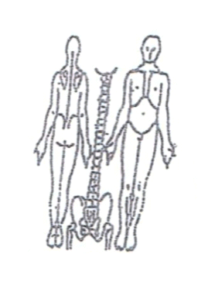**Working Diagnosis:** Pain obstruction syndrome of the neck. Shao Yang Type.

S: Acute attack on the lateral side of the neck and back due to over exercises. Sleep disturbance. ROM ↓.

O:

**Treatment (P**) Acupuncture: DU20, DU14, GB20, GB21 bilateral, TW5, GB39, LI11, LI4, GB34 (bilateral).Reduce level of exercises for the acute period. H7 (bilateral) to reduce nervousness and sleep disturbances.

(A) Acupuncture 1 hour with distal point sedation.

**Date:_ _______________**

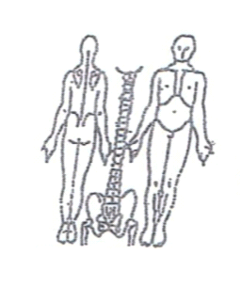**Working Diagnosis:**

S: Pain still the same, with less radiation to the back. Sleep better. ROM ↓.

O:

Treatment (P) Acupuncture 1 hour according to the protocol.

(A)

**Date:_ _______________**

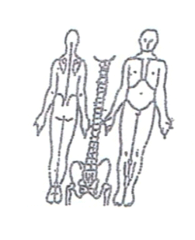**Working Diagnosis:**

S: Pain . ROM . Sleep N. movement. No radiation to pain.

O:

Treatment (P) Acupuncture 1 hour + Moxa.

(A)

**Date:**

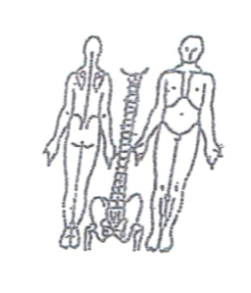**Working Diagnosis:**

S: pain. ROM. N sleep. No tiredness.

O:

Treatment (P) Acupuncture 1 hour + exercises.

(A)

**Date: _**

**Working Diagnosis:**

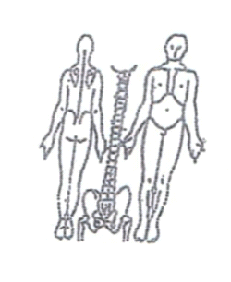S: No pain. N ROM, N level of energy. No daily living limitation.

O:

Treatment (P) Acupuncture + Moxa 1 hour + exercises.

(A)